Voice and Chat Integration - Installation and Configuration Guide
Pre - Requirements:
- .NET Framework 4.7 or greater
- Castle Core 4.0.0.0
Installation:
The Voice and Chat Integration app can be installed using the nuget package Voicify.VoiceChatIntegration from the EPiServer nuget feed.
Configuration:
Once installed, log in as an administrator.
Navigate to the Dashboard’s Settings and select “Add Gadget.”
Select the Voicify Voice and Chat Integration – Regenerate API Key gadget.
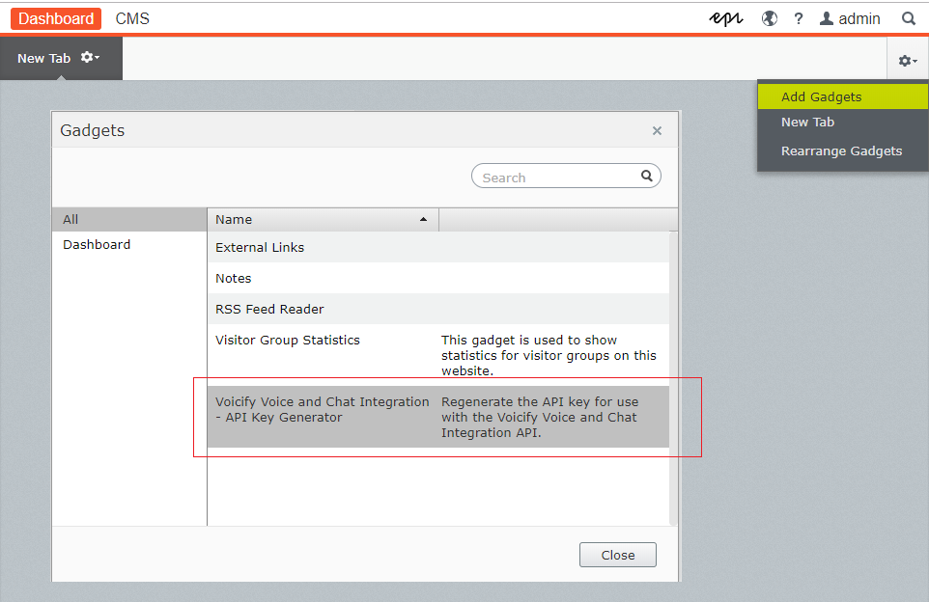
The gadget is now available to generate and re-generate the API Key. NOTE: Only the last generated API Key is considered active. All previously-generated keys are no longer valid.
